Newsletter
Issue 27

19 April 2024

Dear Parents and Carers

Thank you for such a warm welcome to Oliver’s Battery this week. It has been a pleasure to start to get to know the children, families and staff here at school.

I have been visiting classrooms, the playground and lunch hall each day this week. The children have been keen to chat to me about all the things they value and enjoy at school as well as opportunities for improvements. I am looking forward to finding out more over the next few weeks.

Staff and governors have made me feel very welcome too. They have been helpful and thoughtful throughout the week and I have really appreciated this.

It has been lovely to say ‘Good Morning’ to many of you on the gate in the mornings. Thank you too for your encouraging and supportive words. If we haven’t had a chance to meet yet I would love to do so. I will be in the Kingfisher Classroom (Year 6) straight after school on Thursday 25th April for a coffee and a chat.

Miss Sarah Vittle

Winchester Books Festival
The Winchester Books Festival is including a Children’s Books Festival this year and the fun starts with two children’s events a P & G Wells in College Street this Friday. There are events around the city for both children and adults on Friday, Saturday and Sunday this week.

Change of Menu
There will be a change of menu for Monday. The green option will be: Veggie Sausage Puff not Vegetarian sausage roll. The red option is Macaroni Cheese (no change).

Also from Wednesday 24 April the kitchen will be serving Picnic Boxes instead of Jacket Potatoes. The options will be:

Monday – Cheese
Tuesday – Ham
Wednesday – Tuna Mayo
Thursday – Cheese
Friday - Ham

On Friday 3 May there will be NO hot food being served. The choices for lunch that day will be: Ham or Cheese picnic boxes.

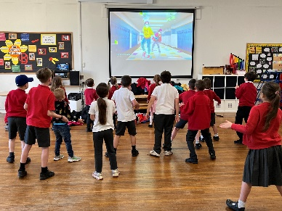
Breakfast Club
A reminder that we run a Breakfast Club each morning from 8am. Children have the option of cereal, toast and fruit juice. This week at Breakfast Club we have been having great fun with ‘Lets Dance’

Lunchtime/Playtime Leaders
The children who were chosen this week were:

Amit D - Ladybirds
Ellie B - Bumblebees
Christopher D - Herons
Pearl C - Herons

Quiz Night

Save the date! The PTA are planning on holding a quiz night for adults on Friday 10 May. Get your team together for a fun night of quizzing, bar, nibbles and prizes.

Learning Behaviours
We have held this week’s Learning Behaviours assembly. This is where a teacher chooses a child/children that has demonstrated the chosen learning behaviour of the week. The teacher shares with everyone what the child has done and then we all celebrate their achievement. This term we are looking at Independence. The children who were chosen this week were:

Year One Isla B
Year Two Nainika N
Year Three William B
Year Four Rosa B-F
Year Five Laura B
Year Six Maya M

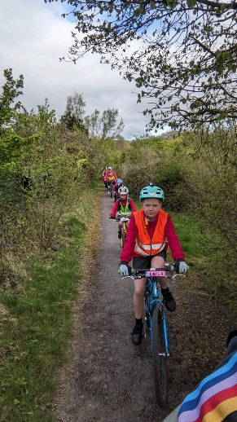
Oliver’s Battery Bike Bus
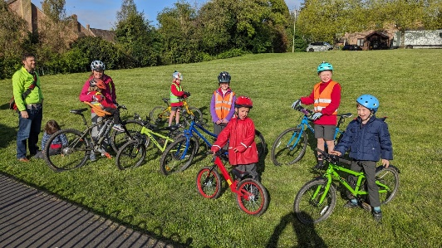
Every Friday this term we will be running a bike bus from the bottom of Rooks Down Road up to the school. We leave at 8.15am from Rooks Down Road and have a stop to pick up more riders at 8.20 at the swings between Ashbarn Crescent and Plough Way. We have a lot of fun and love to have more families join us. For more information contact Anne on 07531 488038.

Play Equipment
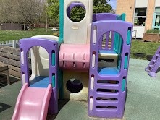
The Nursery school are looking for a good home for this play equipment. If anyone would like it please contact the school office – we are not asking any money for it but any donations would be gratefully received – it would also have to be collected from school.
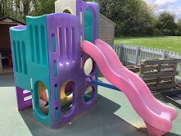

Winchester Brownies
The local Brownies and Guides units have spaces for girls aged 7+ to join this term.

Oliver’s Battery Brownies unit for girls aged 7-10 meet on Tuesdays at 6 – 7.15pm. For more details contact: Kate: 3rdwincitybrownies@gmail.com.

St. Cross Brownies Unit meet on Thursdays 6.30 – 7.45pm. For more details contact: Louisa: stcrossbrownies@gmail.com

St Cross Guide unit for girls aged 10-14 meet on Thursdays 7.30-9pm. For more details contact: Clare: stcrossguides@gmail.com.

School Lunches
Thank you to everyone for settling their lunch accounts, however the lunch debts are still high - please could you ensure that your account is kept up to date. For your information the money owed per class is as follows:-
Hares £
Foxes £
Herons £
Kingfishers £
Nursery £

Please could we ask that your child does not order a school lunch if the debt is above £10.00 and to provide them in a packed lunch. From Monday 22 April your child will not be able to order a school lunch if the debt is over £10.00.

If you would like an up to date statement of your child’s account please contact the Admin Team. If you have not yet registered to pay online via Scopay and would like a copy of your login details please email us and we will be happy to help. We would appreciate it if all accounts, including any outstanding Breakfast Club and After School Club accounts, could be settled as soon as possible. Please ensure that your After School Club Account is up to date as we employ extra staff for this club. If you would like an up to date statement please contact the school office.

Thank you for your continued support.

Yours faithfully

Miss Vittle
Headteacher

Dates for your diary (new dates in red)

Year 5 trip to Ferny Crofts 24 - 26 April 2024
Year 1 trip to Hilliers 29 April 2024
Year R trip to Marwell Zoo 7 May 2024
Inset Day 28 June 2024
Inset Day 1 July 2024
Year 6 Induction day – Kings’ School 2 July 2024
Information Evening – Year 6 Kings’ School 6pm 3 July 2024
School breaks up for summer 23 July 2024

